This is a web based application in which we have to login using a social app, here it is Google Gmail, which navigates the user to the home page. In the home page, the application functionality starts here using search form field before which we need to give the local location.

This application includes four stages:

**Stage 1**: Login in to the social Gmail page leads the user to the home page.



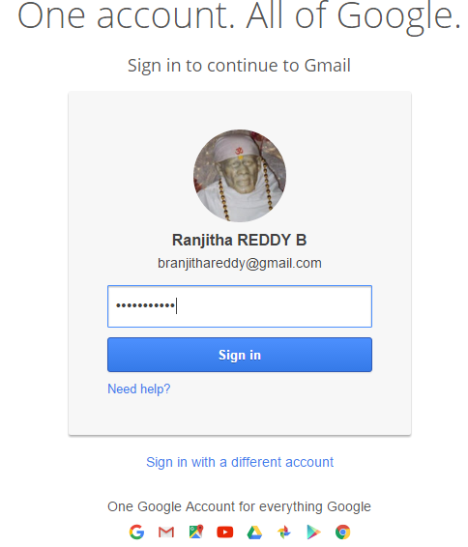

**Stage 2:** Once we login in to the home page, it provides us to locate the city in which we want to search something and along with that one more form field in which we need to enter the key word that we are looking to search for.



Stage 3: After entering the thing for which we are looking, with in no time it displays top 5 results of our search. Then we can see and proceed for what we really want to check.



Stage 4: This is the final stage from which we get reviews and sentiment analysis upon clicking each result.

